RESEARCH REPORT
The Effect of Weather Conditions on Air Pollution in Beijing

Khalidullina Sabina 3rd year ISE

1. Introduction
Air pollution represents one of the most pressing environmental and public health challenges facing modern cities. Beijing, as one of the most densely populated metropolitan areas in the world, has long struggled with elevated concentrations of fine particulate matter (PM2.5) — airborne particles with a diameter of 2.5 micrometers or less that are capable of penetrating deep into the respiratory tract and causing serious health complications.

This report investigates the relationship between meteorological conditions and PM2.5 concentrations in Beijing over the period 2014 to 2023. Specifically, it analyses how relative humidity, precipitation, atmospheric pressure, and wind speed influence daily and monthly PM2.5 levels. Understanding these relationships is essential for developing effective air-quality management policies and forecasting pollution episodes.

1.1 Data and Variables
City-level time-series data were collected from two primary sources: Kaggle and NASA Power. The dataset covers the period January 2014 to December 2023. The following variables are used throughout the analysis:

Variable | Symbol | Unit | Description
PM2.5 Concentration | pm2.5 | μg/m³ | Fine particulate matter — primary dependent variable
Relative Humidity | hum | % | Percentage of water vapour in the air
Precipitation | precp | mm | Total rainfall/snowfall per period
Atmospheric Pressure | pressure | hPa | Surface barometric pressure
Wind Speed | windsp | m/s | Average wind speed at surface level

2. Data Visualisation
2.1 Correlation Matrix
The correlation matrix provides a preliminary overview of the pairwise linear relationships between PM2.5 and the four meteorological predictors.  PM2.5 is negatively correlated with wind speed (−0.34) and precipitation (−0.07), and positively correlated with humidity (+0.23) and atmospheric pressure (+0.16). These patterns are consistent with physical intuition: strong winds and rainfall help disperse or wash out airborne particles, while humid and high-pressure conditions tend to trap pollutants near the surface.  The moderate magnitude of all pairwise correlations indicates that no single meteorological variable fully explains pollution variability, justifying the use of a multivariate regression approach. | 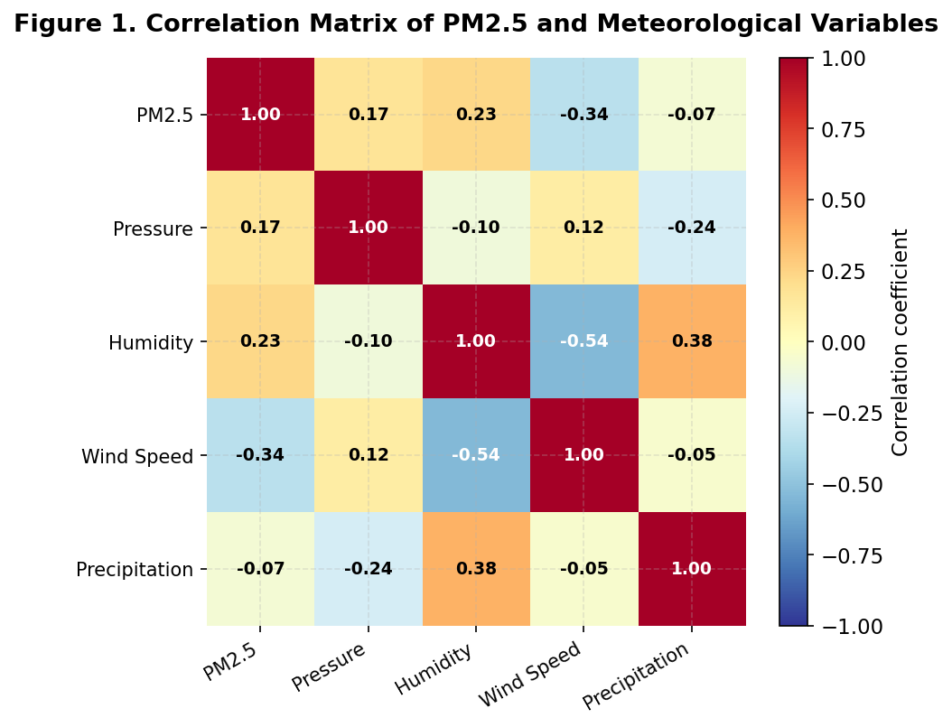  Figure 1. Correlation Matrix (PM2.5 and meteorological variables)

2.2 PM2.5 Over Time (2014–2023)
The monthly time series of PM2.5 concentrations reveals two prominent features: (1) pronounced seasonal cycles with pollution peaks recurring in winter and troughs in summer, and (2) a gradual downward trend over the decade.  The highest concentrations were recorded in the mid-2010s, with values frequently exceeding 200 μg/m³ in winter months — well above the WHO guideline of 15 μg/m³ for annual mean PM2.5. By 2022–2023, the seasonal peaks had moderated to around 120–140 μg/m³, indicating measurable improvement.  The series exhibits clear annual seasonality, with PM2.5 levels consistently peaking during certain months (likely winter) and declining during others. However, the magnitude of these seasonal fluctuations decreases over time, indicating a weakening seasonal effect alongside a downward trend in pollution levels. | 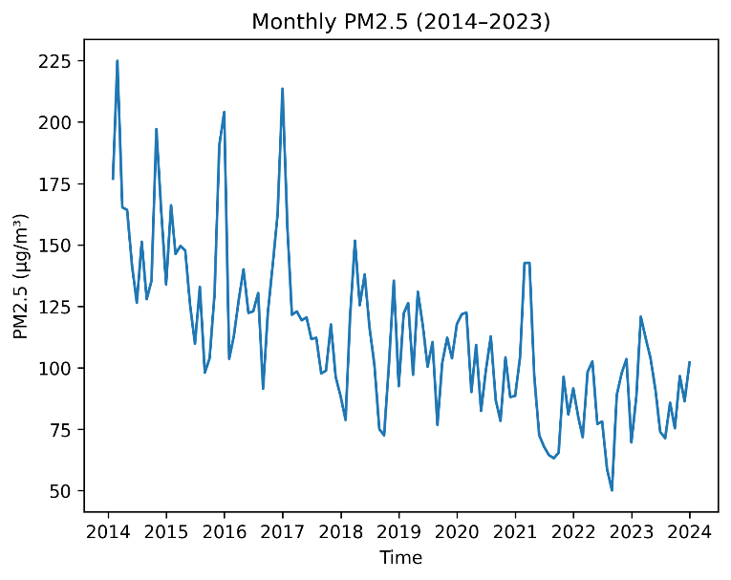  Figure 2. Monthly PM2.5 (μg/m³) over time
2.3 Average PM2.5 by Season
The seasonal bar chart clearly illustrates that winter records the highest average PM2.5 concentrations (~124 μg/m³), followed by spring (~119 μg/m³), autumn (~111 μg/m³), and summer (~95 μg/m³).  The elevated winter levels are attributable to a combination of factors: (a) temperature inversions that suppress vertical mixing and trap pollutants near the surface; (b) increased heating-related emissions from coal burning; and (c) lower wind speeds and precipitation in the cold season.  Summer's relatively low concentrations reflect improved atmospheric dispersion due to higher temperatures, more frequent convective activity, and greater precipitation. These seasonal patterns are confirmed statistically by the regression analysis in Section 4. | 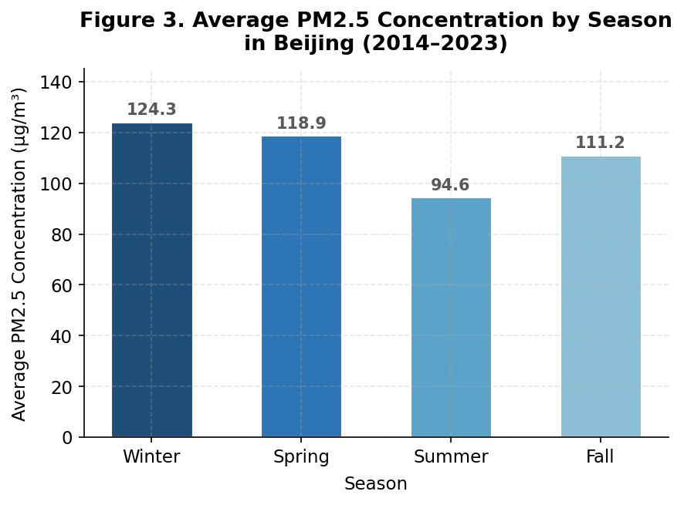  Figure 3. Mean PM2.5 (μg/m³) by season — Beijing (2014–2023)

2.4 Scatter Plots: Meteorological Variables vs PM2.5
The following four scatter plots examine the individual relationships between each meteorological variable and PM2.5 concentrations. A linear trend line is overlaid on each plot to highlight the direction and approximate magnitude of the relationship.

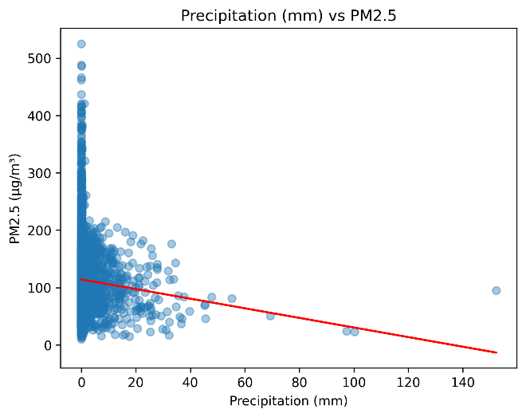  Figure 4. Precipitation (mm) vs PM2.5 (μg/m³) | 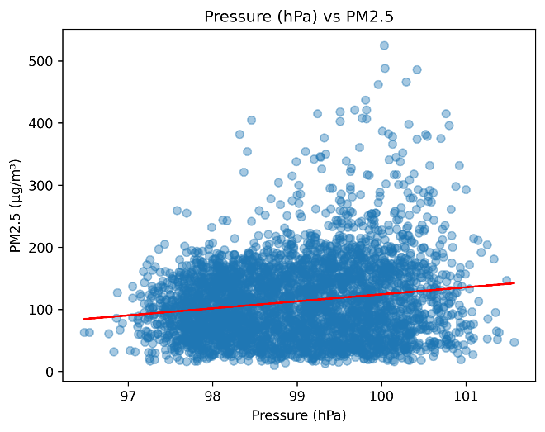  Figure 5. Atmospheric Pressure (hPa) vs PM2.5 (μg/m³)
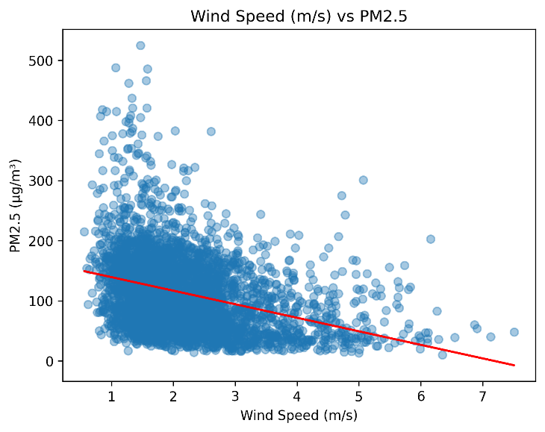  Figure 6. Wind Speed (m/s) vs PM2.5 (μg/m³) | 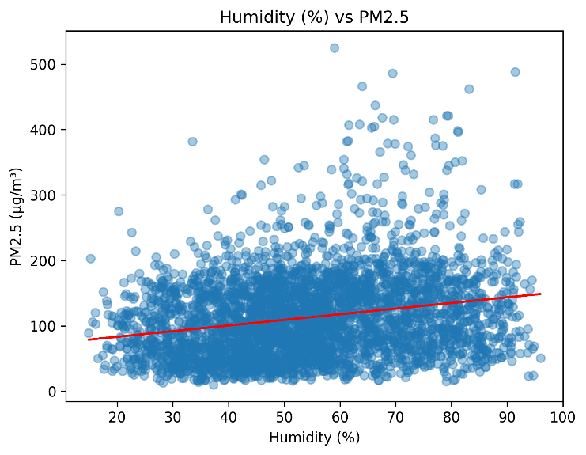  Figure 7. Relative Humidity (%) vs PM2.5 (μg/m³)
Wind speed exhibits the strongest and clearest negative relationship with PM2.5 (Figure 6), confirming its role as a primary dispersal mechanism. Precipitation also reduces PM2.5 (Figure 4), though the relationship is weaker given the high frequency of zero-precipitation observations. Atmospheric pressure shows a weak positive trend (Figure 5), consistent with stable high-pressure conditions trapping pollutants. Humidity is positively associated with PM2.5 (Figure 7), likely due to secondary particle formation under moist conditions.

3. Regression Model & Statistical Testing
3.1 Model Specification
The distribution of PM2.5 is right-skewed; accordingly, the natural logarithm is used as the dependent variable. The model includes two autoregressive lags of log(PM2.5), the four meteorological variables in levels, a linear time trend, and seasonal dummy variables (spring, summer, autumn — with winter as the base category):

log(pm2.5ₜ) = β₀ + β₁ log(pm2.5ₜ₋₁) + β₂ log(pm2.5ₜ₋₂) + β₃ windspₜ + β₄ humₜ + β₅ pressureₜ + β₆ precpₜ + β₇ trendₜ + season dummies + εₜ
Unlike larger particles that settle quickly, fine PM2.5 can stay suspended for days or weeks. PM2.5 concentrations are persistent over time because pollutants accumulate in the atmosphere and disperse gradually. Therefore, current pollution levels depend on past pollution levels.
3.2 Stationarity — Augmented Dickey-Fuller Test
The ADF test strongly rejects the null hypothesis of a unit root for all variables at the 5% significance level. All series are stationary in levels; standard inference is therefore valid and the model does not suffer from spurious regression.

Variable | Test Statistic | p-value | Conclusion
log_pm25 | -11.378 | < 0.01 | Stationary
log_pm25_lag1 | -11.384 | < 0.01 | Stationary
log_pm25_lag2 | -11.385 | < 0.01 | Stationary
windsp | -8.606 | < 0.01 | Stationary
hum | -6.536 | < 0.01 | Stationary
pressure | -3.813 | 0.018 | Stationary
precp | -10.430 | < 0.01 | Stationary

3.3 Heteroskedasticity — Breusch-Pagan Test
BP Statistic | Degrees of Freedom | p-value | Conclusion
258.88 | 10 | < 0.001 | Heteroskedasticity present

The Breusch-Pagan test rejects homoskedasticity. Heteroskedasticity-robust (HC) standard errors are therefore used throughout to ensure valid inference.

3.4 Autocorrelation — Durbin-Watson Test
DW Statistic | p-value | Conclusion
2.0225 | 0.7035 | No serial autocorrelation

The DW statistic is very close to 2 and the null of no autocorrelation cannot be rejected, confirming that the two autoregressive lags adequately capture the dynamic structure of PM2.5.

3.5 Multicollinearity — Variance Inflation Factors
Variable | VIF | Assessment
log_pm25_lag1 | 1.70 | No concern
log_pm25_lag2 | 1.59 | No concern
windsp | 1.53 | No concern
hum | 2.19 | No concern
pressure | 2.56 | No concern
precp | 1.31 | No concern
trend | 1.26 | No concern
spring | 2.43 | No concern
summer | 3.88 | No concern
fall | 1.82 | No concern

All VIF values fall below the commonly accepted threshold of 5, indicating that multicollinearity is not a concern. Coefficient estimates are stable and reliable.

4. Regression Results
4.1 Coefficient Estimates
Variable | Coefficient | Robust Std. Error | p-value | Interpretation
log_pm25_lag1 | 0.514 | 0.0156 | < 0.001 | Strong AR persistence
log_pm25_lag2 | −0.129 | 0.0146 | < 0.001 | Mean-reverting adjustment
windsp | −0.243 | 0.0107 | < 0.001 | Disperses pollution
hum | 0.0057 | 0.00066 | < 0.001 | Promotes particle formation
pressure | 0.034 | 0.0119 | 0.004 | Stable air traps pollutants
precp | −0.0094 | 0.0029 | 0.001 | Washes out particles
trend | −0.00014 | 0.000008 | < 0.001 | Long-run quality improvement
spring | 0.203 | 0.0247 | < 0.001 | +20.3% vs winter baseline
summer | −0.202 | 0.0311 | < 0.001 | −20.2% vs winter baseline
fall | −0.154 | 0.0223 | < 0.001 | −15.4% vs winter baseline
The $R^{2}$of 0.57 indicates that approximately 57% of the variation in PM2.5 concentrations is explained by the model. This suggests a reasonably good fit, although a substantial portion of variation remains unexplained, likely due to omitted factors such as unobserved environmental or behavioral influences.
The F-test rejects the null hypothesis that all slope coefficients are jointly equal to zero, indicating that the model is statistically significant as a whole.
4.2 Interpretation of Key Coefficients
The following bullet points translate the log-linear regression coefficients into economically and environmentally meaningful statements, holding all other variables constant:

- A 1% increase in the previous period's PM2.5 leads to a 0.51% increase in current PM2.5 — confirming strong short-run persistence in pollution levels.
- A 1 m/s increase in wind speed reduces PM2.5 by approximately 24.3% — the single largest meteorological effect in magnitude.
- A 1 percentage-point increase in relative humidity raises PM2.5 by approximately 0.57%, consistent with the hygroscopic growth of particles.
- A 1 hPa increase in atmospheric pressure raises PM2.5 by approximately 3.4%, reflecting suppressed vertical mixing under stable conditions.
- A 1 mm increase in precipitation reduces PM2.5 by approximately 0.94%, reflecting wet deposition of particles.
- Time trend:PM2.5 decreases by approximately 0.014% per day — equivalent to a modest but statistically significant structural improvement in air quality.
- Seasonal effects: Spring concentrations are approximately 20.3% higher than winter; summer is 20.2% lower; and autumn is 15.4% lower.

The seasonal patterns observed in the descriptive statistics differ from the regression results because the bar chart reflects unconditional averages, while the regression estimates isolate the ceteris paribus effect of each season. The raw averages combine seasonal effects with other factors such as time trends, meteorological conditions, and persistence in PM2.5 levels. In contrast, the regression controls for these factors, allowing us to identify the independent contribution of each season. This explains why the estimated seasonal coefficients differ from the simple seasonal means.

4.3 Long-Run Effects
Given the autoregressive structure of the model, the long-run (cumulative) effect of each meteorological variable is calculated as: Long-run effect = β / (1 − β₁ − β₂).

Variable | Short-Run Effect | Long-Run Effect | Amplification Factor | Interpretation
windsp | −0.243 | −0.395 | 1.63× | Strong cumulative pollution reduction
hum | +0.0057 | +0.0093 | 1.63× | Modest cumulative increase
pressure | +0.034 | +0.055 | 1.63× | Moderate cumulative increase
precp | −0.0094 | −0.0153 | 1.63× | Cumulative reduction via wet deposition

In the long run, a sustained 1 m/s increase in wind speed would reduce PM2.5 by approximately 39.5%, underscoring the critical role of atmospheric circulation patterns in determining Beijing's air quality.

5. Forecasting — Holt-Winters Model
The Holt-Winters exponential smoothing method was selected for forecasting given that the PM2.5 series exhibits both a downward trend and clear seasonal structure.  The smoothed series closely follows the trajectory of observed data, successfully capturing recurring seasonal peaks and troughs. The forecasted values extend this seasonal pattern into 2024, maintaining the gradual downward trend identified in historical data. | 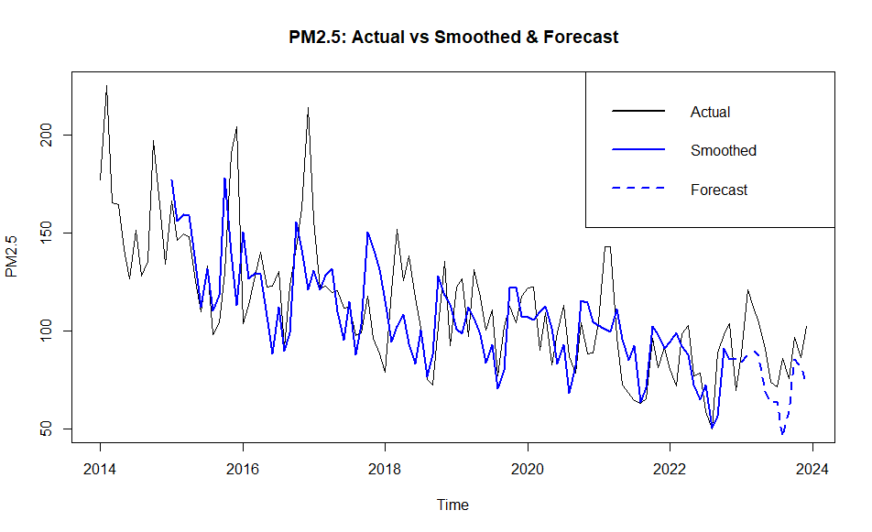  Figure 8. PM2.5: Actual vs Holt-Winters Smoothed & Forecast

Model performance was evaluated on a hold-out evaluation sample:

MAE | 18.14 μg/m³ — average absolute  forecast error

RMSE | 21.21 μg/m³ — penalizes larger errors  more heavily

MAPE | 19.25% — reasonable predictive  accuracy for monthly PM2.5

The MAPE of ~19% indicates that the Holt-Winters model achieves reasonable predictive accuracy for this application. The model performs well in tracking seasonal dynamics but underestimates the magnitude of sharp pollution spikes associated with extreme weather events — a known limitation of smoothing-based approaches.

6. Conclusion
This study has examined the determinants of PM2.5 concentrations in Beijing over the period 2014–2023 using a dynamic multivariate regression model and Holt-Winters forecasting.

The principal findings are as follows:

- Wind speed is the most powerful meteorological driver of air quality, with a 1 m/s increase reducing PM2.5 by ~24% in the short run and ~40% in the long run.
- Precipitation reduces pollution through wet deposition, though the effect is modest and intermittent due to Beijing's dry climate.
- High atmospheric pressure and elevated humidity are both associated with increased PM2.5, reflecting conditions that suppress atmospheric dispersion.
- Strong seasonal effects persist, with winter consistently recording the highest pollution levels due to temperature inversions and heating emissions.
- A statistically significant long-run downward trend in PM2.5 suggests that policy interventions (emissions controls, fuel switching) have contributed to gradual air quality improvement over the decade.
- The Holt-Winters forecasting model achieves a MAPE of ~19%, offering useful but imperfect predictions of seasonal PM2.5 dynamics.

These findings have direct relevance for urban air quality management. Policies that account for forecast meteorological conditions — especially wind and precipitation patterns — could help anticipate and mitigate acute pollution episodes. Future research should incorporate spatially disaggregated data and additional emission-source variables to further improve model accuracy.

